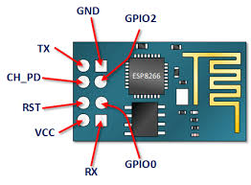

To upload software to esp8266 chip must be in programming mode :

Wiring

|  |  |  |
| --- | --- | --- |
| esp8266 | Arduino | Power Supply |
| RX | RX |  |
| TX | TX |  |
| VCC & CH_PD |  | 3.3 V |
| GND & PGIO0 | GND | GND |

MUST keep Arduino Reset Button Hold while uploading software

To run the software keep wire as it is but remove GPIO0 connection from Arduino.